Intrusion Detection Systems
By Ethan Beasley and Aidan Flynn
4/23/2026

Introduction:
An intrusion detection system is a multi-stage security system which monitors proximity, sound, and motion to alert a user of any potential threats around the area that is being protected by the system. The system we’ve designed uses 2 sensors, the HC-SR501 PIR Motion Sensor Module and a standard breakbeam sensor to create an efficient detection system whilst keeping a low-price cost. This system works through a NUCLEO-F446RE board, which allows the use of FREERTOS for the sensors to work in tandem with each other safely and without large system overhead.
Bill of Materials:
Item: | Cost:
HC-SR501 PIR Motion Sensor Module | $14.00
Nucleo-F446RE | $31.00
OLED Display | $6.00
Breakbeam Sensor | $10.00
Total | $61.00
Methods:
Our system is comprised of 3 tasks, one handles the OLED refreshing, one handles the PIR, and another handles the breakbeam sensor. The individual sensor tasks wait for a semaphore from the respective sensor to activate, before sending a message corresponding to the sensor to the OLED. The OLED then sorts what message to send based on the tag of the data in the queue, for example if the value is a 1, it will play a message for a breakbeam sensor. We did this to allow for modularity in future design iterations.
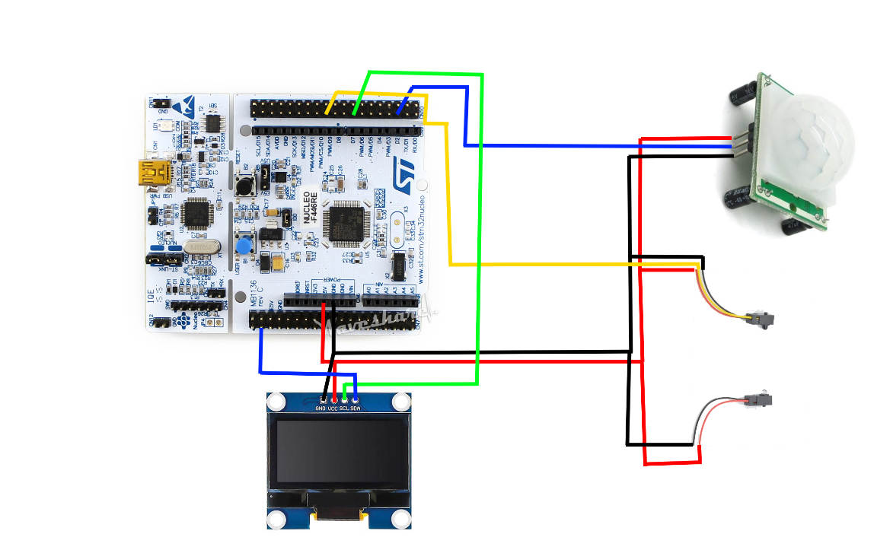
Figure 1: Wiring Diagram
Discussion/Results:
One interesting discovery made was that the breakbeam sensors perform better in a dark room. We can only theorize it is due to refraction of light reaching into the UV spectrum and acting as a false positive. After making that discovery and messing around with it, we found that the PIR sensor has a 60 second wake-up period before it can start sending signals. It does this because it is stabilizing the sensor and normalizing it to its environment, before it can detect anomalies. Our project worked as good as it could have given the circumstances and provided a low overhead solution to a common problem of security.
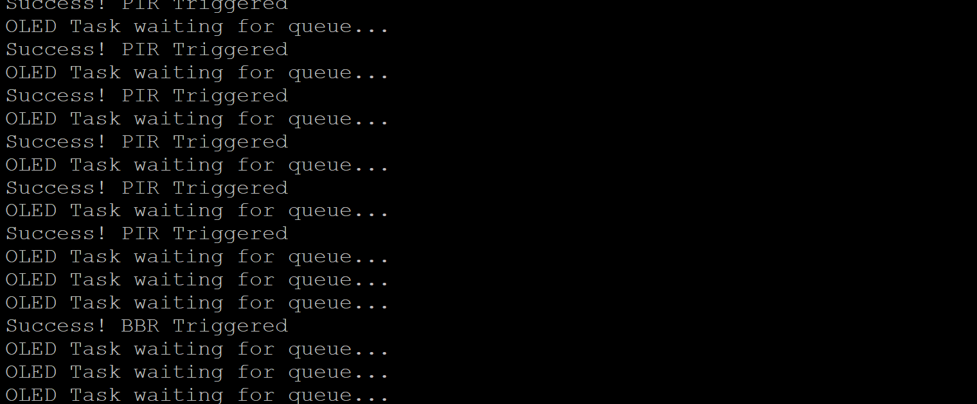
Figure 2: Successful triggering of both sensors
Conclusion:
The application of motion and breakbeam sensors allows for an effective combination of detection equipment to create a secure environment. The use of FreeRTOS allows us creates an effective intrusion detection system through priority based scheduling. This project allowed us to gain more knowledge in the application of semaphores and queues by working with multiple sensors that use external interrupts as their primary mode of communication.

Acknowledgements:
We would like to thank Dr. Ngo and the ECE department of Florida Poly for giving us the opportunity to learn more about FreeRTOS and embedded systems. These applications are critical to the future of local compute and low-cost devices that we use every day.

References:
Ngo, Hoan. "Semaphores" Embedded Operating Systems, Date published/presented, Florida Poly Canvas CDA3631, https://floridapolytechnic.instructure.com/courses/10013/files/7949227?module_item_id=629089.

Github Link:
https://github.com/dattiloxml/SecuritySystem2
Video:
https://drive.google.com/file/d/1O-FUHMzP54iTbFcUudIoaQTkbNLEy9Pv/view?usp=drivesdk

